Oil Market Notes
Crude Driving the Global Economy
I think the key to forming a tactical view for my portfolio will be to understand the potential outcomes of oil markets for the next 6 months and assign probability weightings and respective trades or changes in allocation when probabilities become more likely.
Despite the disturbance to the strait of Hormuz, an oil export route that transported 21.6 MB p/d pre the Iran US war (Q4 2025) to a low of 4 MB p/d (Q2 2026, we saw oil prices fall from $118 a barrel at the end of April to $72 a barrel at the end of June.
This price decline can be attributed to 4 broad reasons:
- Demand destruction
- Dark Transits
- Rerouting
- Inventories
Demand Destruction
Many analysts projected a slight destruction in demand, consensus being hundreds of thousands, what we saw in reality was closer to 8 MB p/d.
Asian Trade Flows
Oil movements through the Strait of Malaca fell from:
- 24.9mn b/d in Q4 2025
- To 21.3mn b/d in Q1 2026
- To 16.6mn b/d in Q2 2026
A 8.3 MB p/d or a 33% decline between q4 2025 and q2 2026.
This isn’t a pure measure of demand destruction, much of this will be explained by supply shortages, rerouting and other factors.
Key Affected Asian Countries
China
Chinese crude imports have moved from approx. 7mn b/d in June (41.3% lower than the previous year) to 8.6mbpd in august. A 23% increase MoM and an indication of demand destruction normalising.
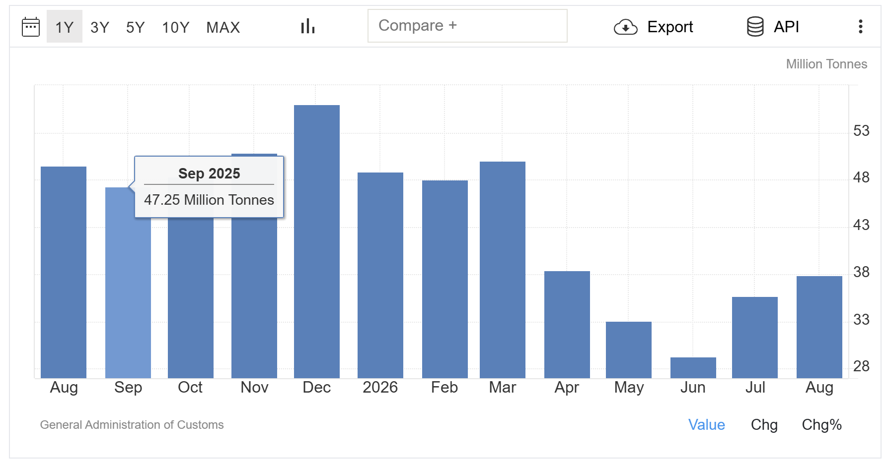

It will be interesting to see Chinese crude oil import figures for September.
How much Chinese demand has really been destroyed?
https://www.reuters.com/business/energy/china-oil-demand-fall-89-2026-sinopec-research-says-2026-09-09/
mentions that Sinopecs research arm forecasts Chinas oil demand will fall 3.9% in 2026. This will make the third consecutive year of contraction.
With 2026 estimates of:
- Gasoline -8.7%
- Diesel demand -11.7%
- Jet fuel +1.7%
This data is equivalent to around 600,000 bp/d decline. Partly cushioning the loss of Middle Eastern supply.
India
India has replaced disrupted gulf barrels through alternative suppliers. India is currently sourcing C.47% of their oil via Russia.
What increase is this?
How could it be affected?
I think this and other Asian countries research for oil comes down to economically modelling and seeing how my portfolio could be affected.
Like if refinaries are being blown up in Russia how does this affect india.
So many questions can be formed.
Inventories
Get new data and examples, how it is now being affected.
Feel like a lot of this is historic.
Need to wrap this up then go onto say what about oil today…… and my view, then I can do some quantitative economic modelling and plan my portfolio allocation changes or potential trades around this.
The approximate global inventory draw up to X date was 566mn barrels. If we compare this to the Hormuz flows, if we lost 8mbpd in the strait of Hormuz upp to X date then we can estimate that the reserves accounted for C.Y% of global oil supply.
Global observed inventories were 509mn barrels below end-Feburary levels by the end of September. An approximate draw of 2.4mb/d. you could take a rough estimate that (2.4/8 = 0.3) 30% of supply lost from the strait of Hormuz was replaced by inventories.
Don’t think I need too much more here – follow up later with what is happening with inventories now, where I think oil is headed.
I’ll do a separate section on refineries too

Dark Transit
According to Kpler, the seven day average of non-Iranian crude leaving through the strait of Hormuz dropped 72% after the war began.
By September, Kpler estimated that non Iranian crude was leaving through three routes;
Route | Share |  | Approximate flow
Directly through Hormuz |  | 60% | 9.9 mb/d
Loaded outside Hormuz, principally Fujairah | 23% |  | Approximately 3.8 mb/d
Saudi Red Sea route | 17% |  | Approximately 2.8 mb/d
How does this work?
A tanker would:
- Load crude inside the Gulf.
- Switch off its AIS tracking signal.
- Cross Hormuz using a shuttle corridor.
- Transfer the crude to another vessel near Fujairah or Sohar.
- Return inside the Gulf while the second vessel continued to Asia or Europe.
Kpler identified:
- At least 63 VLCCs operating in the shuttle trade.
- A core fleet of 35 vessels accounting for approximately three-quarters of shuttle voyages.
- Typical shuttle cycles of roughly 16 days.
- More than 70% of August crude crossings subsequently using ship-to-ship transfers outside Hormuz.
- Transfers split approximately 54% at Fujairah and 45% at Sohar. Kpler -
Tankers using the designated corridors stopped broadcasting AIS positions: Kpler recorded 13 broadcasting journeys in March but none by May. It instead used satellite imagery, vessel draught changes and destination-port checks to reconstruct the journeys.
On 21 September, satellite imagery reportedly showed five tankers loading simultaneously at Iraq’s Al Basrah terminal while none broadcast their position.
Rerouting
The physical supply shock was partly offset by Gulf producers rerouting crude through pipelines and export terminals located outside the Strait of Hormuz.
There are two major operational pipeline routes and one smaller Iraqi route:
- Saudi Arabia’s East–West Pipeline to Yanbu.
- The UAE’s Habshan–Fujairah Pipeline.
- The Iraq–Türkiye Pipeline to Ceyhan.
Exports through the main bypass routes increased from approximately:
- 4.1 mb/d in February.
- To 7.8 mb/d in June.
- Before falling to 5.5 mb/d in August.
- And recovering slightly to 5.6 mb/d in September.
The June increase of 3.7 mb/d was equivalent to approximately 18% of total pre-war Hormuz flows. Across the period to the end of August, the IEA estimates that additional bypass activity replaced more than 500mn barrels of lost Hormuz exports, or an average of approximately 2.8 mb/d.

